CHA Blogs in 2020

Care for the Carers

There is concern about how best to support those staff who are caring for others during covid-19, and that includes all staff in the health and social care sectors. These are examples of the way that carers are being shown how they may access support. We know from talking to staff in community hospitals that there are particular challenges to staff working in remote and rural areas. Please share with us what has been helpful to you.

Gloucestershire - Caring for those who care

This is helpful in terms of supporting those who are caring for others.

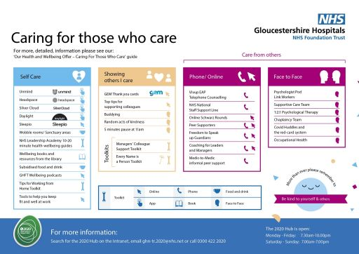

Accessing Support During Covid-19

This has been issued by the NHS, summarising support to staff.

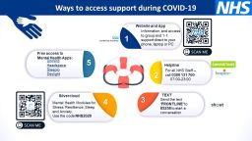

Patient Safety Stories

The Patient Safety Learning website has launched its #safetystories
"How is the coronavirus impacting other areas of your care or treatment? Share your #safetystories"
Read more

Covid-19 Community Hospitals Meeting the Challenge

There are particular challenges in supporting local communities in remote and rural areas. Small local hospitals are contributing in a variety of ways.

Covid-19 Units - becoming dedicated units to support patients who have Covid-19 such as Tewkesbury in Gloc. and Ottery St Mary in Devon
Rehabilitation and Step down care - continuing to provide a service to patients (non-Covid-19) who can be safely transferred out of acute hospitals
Palliative care for all patients
Ambulatory care such as hosting a chemotherapy unit moved from an acute hospital such as Shotley Bridge in Durham
Nursing Resources - Redirecting community staffing, and closing facilities such as minor injuries - such as in Holywell, Wales; Johnson Hospital in Lincs.

Please let us know how your community hospital is being utilised to support patients and families during this crisis.

Coronavirus - Community Hospitals and the Vital Importance of Connecting

Thank you for all that you do. Thank you for your generosity in sharing what you are able to achieve within your communities. Within minutes of sending out our latest CHA newsletter, we had many emails telling us what was happening and thanking us for support. This is a selection. Many of these could only be achieved through the work over the years to create strong relationships across the community. Lets keep connected.

*Honiton Coronavirus Support Network
“The League of Friends have redirected our time and energy to setting up the Honiton Coronavirus Support Network. We are well placed to have input with these networks as we have good links with our Health and Care teams and GP surgeries. We now attend a daily Community Team virtual meeting so we are all in this together. We got this together in 48 hours which is outstanding and down to the commitment and kindness from many people. As the statutory services get busier we are more and more in the front line and making pretty major decisions on a daily basis. Good working relationships across the organisations is crucial.”
Heather Penwarden Chair of Honiton Hospital and Community League of Friends

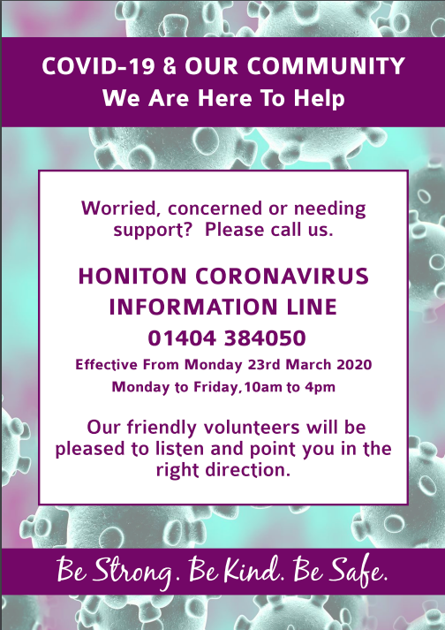

*Bishops Castle - GP Initiatives

​“Thanks all good here. No PPE yet promised for next week. We have put forward plan with community hospitals as hot hubs for the community and with 7 day cover by GPs. Our equipment fund have come up with immediate grant to allow us to work remotely ; i.e. pay for 6 enabled laptops support with equipment PPE and staff in addition to linking closer with local undertaker ( who has been left out of planning cycle entirely)”
Adrian Penney GP Bishops Castle

* Fleetwood - Staying Connected
“If you could keep me in the loop please. Stay healthy and more importantly stay happy during this uncertain time and thank you for considering me.”
Kelly Garrick Fundraising Manager Fleetwood Trust

* Rye Hospital Charity - Community Support
“Everyone is pulling together quite remarkably.”
Barry Nealon Chairman of Rye Health and Care, Rye Hospital

Please share your experiences with us, to help others.

